Documentation for RyanAir’s Code Challenge:   
Booking up a flight with a wrong credit card number and catch payment declined message

**Author:** Brayam Núñez.  
github: <https://github.com/brayamnunez/automationFramework_ui>

The given Code Challenge was to automate a booking up process for a flight, entering a wrong credit card number (actually, just a valid fake credit card) and catch the declined payment error. I decided to tackle this situation through a customized Test Automation Solution that I’ve been developing, which has the following technologies:

* Java.
* Selenium WebDriver.
* Cucumber.
* Maven.
* TestNG.
* Others.

The Test Automation Solution Framework has a maven architecture, where the **src** folder resides code such as:

* Page Objects classes.
* Steps classes.
* Utilities classes.
* Property file.
* POJOs classes.
* Others.

In the **test** folder, reside:

* Features Files (cucumber files)
* Resources: webdrivers
* Runners classes.
* Others.

One important folder to mention is the: **target,** where it resides the **report.html** that ExtentsReports module generates after finishing a **test** **run.**

To set the project up and running:

* You must have maven installed and java.
* Clone it from github and import existing project with maven option on: eclipse or intellij (used).

To run the tests:

* Go to: test/java/runner/MainRunner.class and run it as TestNG.
* Go to: rest/java/runner/

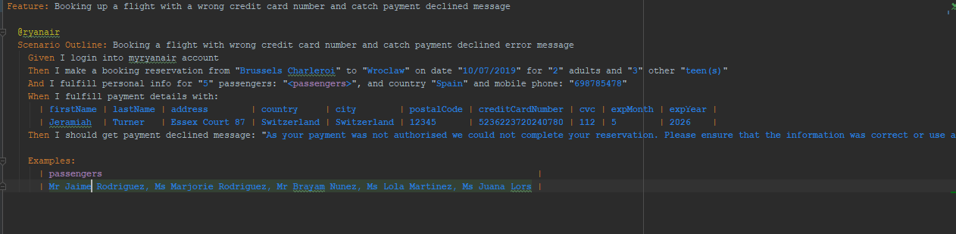  
This is the cucumber file that I implemented in order to tackle the situation:

Explination:

Given I login into myryanair account

First, as I need to have an account to proceed with the payment process, I created a “myrainairaccount”, in order to continue. This credentials are located in the Property file: **src/main/java/properties/config.properties**

Then I make a booking reservation from "**Brussels Charleroi**" to "**Wroclaw**" on date "**10/07/2019**" for "**2**" adults and "**3**" other "**teen(s)**"

I proceed to select the departure airport, and destination airport. What I basically did is input the names of the airports in the corresponding input fields, wait for the autocomplete list shows up, grab all the elements of the list, search for the one that I’ve indicated previously, and when it finds it, it performs a click on the corresponding airports.

When it comes to select the date, I’m selecting a **One-Way** flight, so it will click on the calendar and select just 1 date. When is about to select the date, I pass through cucumber the date for departure, and it tries to find that date on the calendar by @data-id attribute=inputted date, and when it does it clicks on it.

I’m putting the number of adults and others, which it could be: children, teens and infants, so It will click that number of times in the UI.

And I fulfill personal info for "**5**" passengers: "**<passengers>**", and country "**Spain**" and mobile phone: "**698785478**"

Examples:  
 | **passengers** |  
 | **Mr Jaime Rodriguez, Ms Marjorie Rodriguez, Mr Brayam Nunez, Ms Lola Martinez, Ms Juana Lors** |

For fulfilling the personal info for the number of “n” passengers, I decided to pass a separated-by-coma list of passengers (Mr John Doe, Ms Clara Doe), where I pass information such as: title, name and lastname. What I did was to grab the whole list, store it into another separated-by-space list (to have all the properties of the passengers), and then associated to a HashMap, as the UI generates the number of input for passengers dynamically, I can dynamically find each passenger input to fulfill by xpath index, loop and pass each corresponding information based on the number of passengers, more details in the code.

Then, I just provide a country and a phone number to proceed with the process.

When I fulfill payment details with:  
 | **firstName** | **lastName** | **address** | **country** | **city** | **postalCode** | **creditCardNumber** | **cvc** | **expMonth** | **expYear** |  
 | **Jeramiah** | **Turner** | **Essex Court 87** | **Switzerland** | **Switzerland** | **12345** | **5236223720240780** | **112** | **5** | **2026** |

In order to fulfill the payment and billing address information of the person that is going to make the payment, I chose the datatable functionality from cucumber. I created a POJO to persist all the information passed through the previously datatable (DDT), and then loop through them and select the info that I need to input in the UI.

Then I should get payment declined message: "**As your payment was not authorised we could not complete your reservation. Please ensure that the information was correct or use a new payment to try again**"

For the last step, I passed the direct error message that is prompt in the UI, and I make an Assert validation point, to check whether is the exact same message, after I click on “Pay Now” button.

**NOTES:**

* In order to get a fake valid information of a credit card, I used this website: <https://ccardgenerator.com/generat-visa-card-numbers.php>
* The Test Automation Solution has ExtentsReports Module implemented, it shows a easy-to-read report with all the relevant information about the test.
* When tests fails, it takes an screenshot and saves it in: imgs/filename.jpg

**Challenges Encountered:**

* Wait for an element to be clickable, or visible, or sometimes I needed to perform a scroll, or an action to move, in order to go to the element and click it.
* Sometimes when typing a departure and destination airport, it doesn’t shows any autocomplete finds, and test fails.
* Some elements of the page couldn’t be clickable by standard selenium click(), I had to click them through JavascriptExecutor object in order to perform JS behaviors, such as: click, scroll, etc.
* As of now, I’m selecting an available date that could be selected as first option, because sometimes when searching for an exact date, it may be available, or may not in the UI.
* For selecting an adult and children, it’s quite a challenge because the children must be seated with an adult, I just could get to working to generate random seats as for adults and children, but not to seat them up together. Other combinations such as: adult and teen I just click in the UI to select random seats for me.